**DATA VISUALIZATION**

**(BA 54050 – 001)**

**FOCUSING ATTENTION**

**DIVYA CHANDRASEKARAN**

**ID: 811284790**

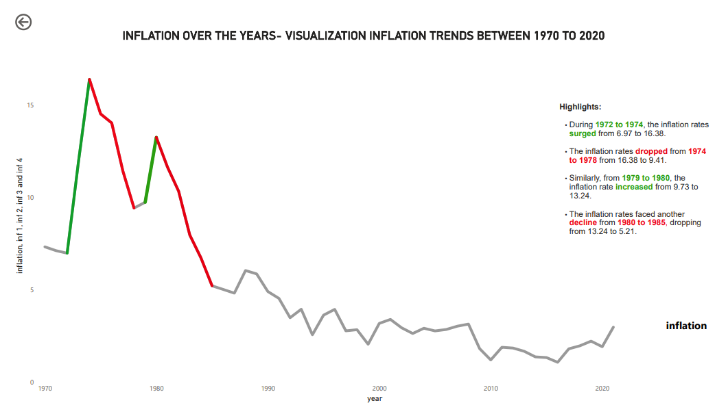

For this assignment, I have imported the OECD data set, and constructed a **line graph** in PowerBI highlighting the specific portions using “intentional color choices”.

For example,

From the line graph, we can see that the years from **1972 to 1974** are highlighted **green** in color indicating there’s an increase.

Similarly, the years from **1979 to 1980** are also facing an increase in inflation rates, and I have used the same **green** color, however, I have saturated the green color a little bit to show some **variation** in color.

In the case of declination, the years from **1974 to 1978** are highlighted in **red** to show that there’s a significant decline in inflation rates.

Similarly, the years **1980 to 1985**, have been highlighted in red, however utilizing contrast, and showing some saturation of **red.**

I have incorporated few decluttering techniques like:

1. Having white space for graph.
2. Removing the gridlines.
3. Eliminating borders.
4. Hiding data markers.
5. Simplifying axis labels.
6. Labelled series directly.
7. Ensure consistent color usage.
8. Removed unnecessary data labels.
9. Included an engaging title.
10. Ensured clear and properly formatted axis titles.
11. Aligned texts appropriately.